It’s taken me awhile to find the best way to write about my experiences from the 117th Boston Marathon, because it’s impacted my life in an entirely different way than I expected. However, I realized there is no right way to tell it. Like anything, the best way is to just begin.

“Your job is to get your singlet back to Boston.” – Jack Fultz, Boston Marathon 1976 winner and Dana-Farber coach (and kind of my hero)
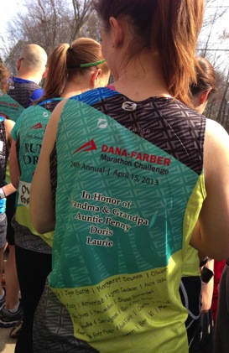
Race Day
At 6 A.M. we boarded the buses to Hopkinton. Runner’s Village was alive with runners! They were bumping the jams when we walked in. Our start time wasn’t until 10:40 A.M., so we did our last minute prep, affixing Gu packets, and decorating our singlets, arms, and legs with temporary tattoos and sharpies. I wrote my given nickname “More Cowbell” across my chest. (If you haven’t seen that SNL skit, get on it.) Laurie had also given me a button picturing her sister, who had done the Boston Marathon year-after-year before passing away from brain cancer. She wanted me to take her on one last run. I fastened my button on my singlet and followed my teammates to the starting line. I had my mission: get my singlet and button safely back to Boston. My nerves were on high alert. When we first started, all you could see was a sea of runners in neon going down the first hill. One of my teammates turned to me and said, “If you start feeling tired, just stop being tired and be awesome instead.” I could not stop smiling. We were doing it! We were running the Boston Marathon!
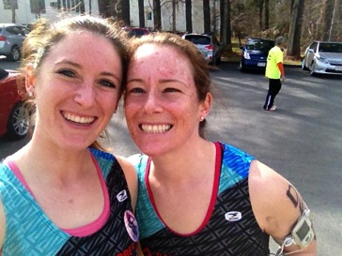
Each of the 8 towns we ran through were lined with people cheering, ringing cowbells, giving high-fives, and providing so much support to the runners. There were so many hilarious signs. There were awkward cheers of “Go…Kovi?” and “Go More Cowbell?” Turns out “Kovi” is hard for people to cheer. I might have to adopt a name like Anne or Kate next time or maybe a “Hey Girl” like those Ryan Gosling memes going around.

I saw Team Hoyt, and Santa, and bandit runners dressed as hamburgers, which prompted a lot of people shouting “nice buns” for quite some time on the course. (And hey, I’m not complaining.) I passed teammates and shared high-fives and fist bumps all along the way. I fell comfortably into my pace behind another Dana-Farber runner, whose singlet read “For brother.” It was a constant reminder of why we were running.

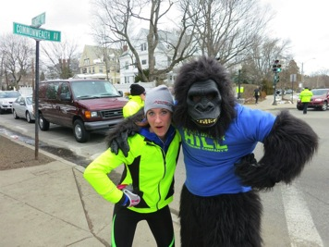
The first 17 miles were a blur of excitement. Dana-Farber had cheering sections all along the route. I had run this route many times with my teammates prior to the marathon so I knew what was coming once we hit the “Newton flats,” as Jack likes to call them. They are anything but flat, and at the end lies the infamous Heartbreak Hill, also the spot where the Heartbreak Hill gorilla hangs out during marathon training season providing support to runners.

I had been checking my watch at each mile to make sure I was staying on pace and not getting too caught up in the excitement of the crowd and race and taking it slow in the beginning. Jack had told us, “It’s a 17-mile warm-up and a 9-mile race.” At mile 17 I abandoned my watch-checks and just soaked it all in. As I was climbing what seemed to be a mountain after running 17 miles, someone called out, “This isn’t heartbreak.” Thank you, sir. Thank you. I was exhausted. Then I saw Julia and Eugene (who I ran my very first half marathon with) cheering on the hill! Then Glen telling me you’re making great time, and then David at mile 19, all giving me those extra boosts of motivation to keep going!

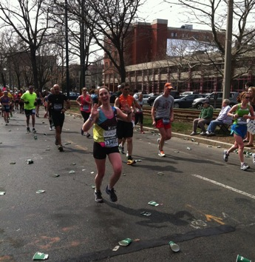
Mile 24
I knew as soon as I crested Heartbreak I was home free, running past Boston College and BU alumni friends near Coolidge Corner, and then by my apartment on Beacon Street (one of my favorite parts of Boston) and spotting my roomie who took this awesome pic! At each point I started to feel tired, there was someone I knew cheering, providing support when I needed it most. Each city was alive with celebration, but once I hit Boston the crowds really picked up and I saw so many people I knew.

Mile 25

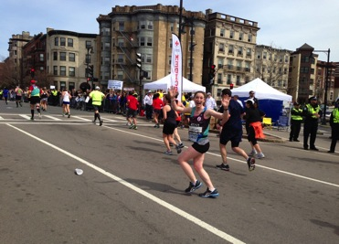
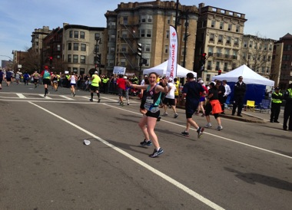
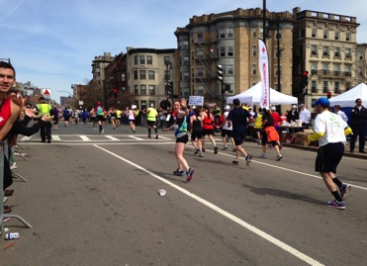
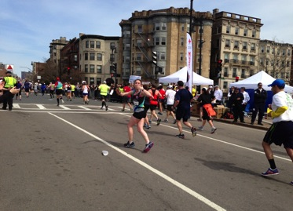
When I turned to blow kisses at Micha and Greg at mile 25, my right leg started to spasm. Oop, that’s not good, I told myself and quickly turned back to finish the last 1.2 miles, passing the infamous Citgo sign. Then I slowed down. I hit the point of the route that dips down under an overpass and pops you back up on Hereford Street, which feels like a mountain after 25 miles. As I was coming up from under the bridge, I heard cheers from Eric and Laura looking down from the bridge. It caught me completely by surprise and was exactly what I needed! Then I saw my mom and Laurie on Hereford Street. They were standing at the very spot I had first watched the marathon on my visit to Boston 3 years ago. We had agreed that was the perfect place for them to watch and the whole time I was running I just knew I had to make it there to see them. I had this strange pull and feeling that I needed to be there. I had planned on stopping and giving hugs, but my legs wouldn’t let me. That cramp told me if I stopped, I would not start again. There would be time for hugs later, I told myself.

Mile 26
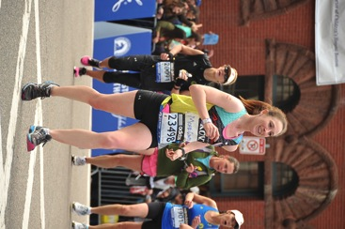
Rounding the corner of Hereford St., I spotted the finish line. After I zeroed in on the larger-than-life finish, everything blurred. Maybe it was from delusion or exhaustion, but as I was running that last .2 miles, the crowds on the sidelines and in the stands merged into one and all that remained in focus was the finish. So many months of long hours of training (in the snow and sleeting rain) and fundraising had gone into this moment. 3 years ago I had never dreamed I would be running a marathon, let alone the Boston Marathon. Hands raised (and making sure not to get blocked by the tall man for the cameras ), I crossed the finish line, completely spent and happy. I finished in 3:50:33 (different from the clock below because of start time), way under what I had expected!!

I was still running off of adrenaline when I spotted Jack Fultz and Jan (the lady behind the Dana-Farber Marathon Challenge team) greeting me at the end. We took pictures and he signed my singlet per my pestering request. I could not stop smiling. It was the happiest moment of my life.

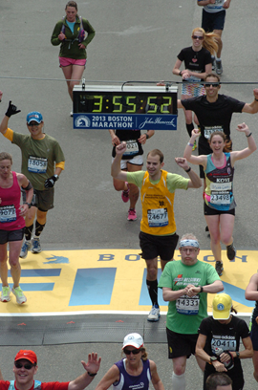
Finish Line
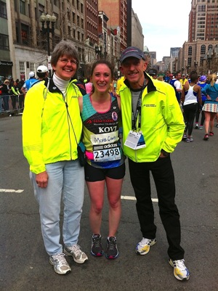
I made my way through the stations getting my mylar blanket, medal, and food. I was getting my bag off of the buses on Boylston Street when the first bomb went off. It sounded like a cannon. Then the second one went off. I saw the smoke and knew something wasn’t right. Time slowed down. I knew my mom and Laurie would have followed me down Boylston to the finish. I didn’t know where they were in relation to the smoke. Thankfully, I had my phone so I could try to call them, but my calls weren’t getting through. Then I got through to her voicemail. No answer. My heart sank. She always answers her phone. We were all supposed to meet at the Marriott. I wandered down Berkeley Street tired and worried. They were readjusting the barriers. A mom of a different runner, saw me and asked if she could help me with my blanket. It was falling off. I acquiesced and then just broke down. I told her I couldn’t find my mom. This kind stranger walked with me all the way to the Marriott, talking to me to calm me down. I am so grateful for her and her family, complete strangers who took me under their wing. We made it to the hotel, but I didn’t see all of my teammates, several I would later find out were close to the finish and had had similar experiences of complete strangers helping them. Micha, Greg, and Eugenio were able to get through to my phone and come get me. I am so grateful for them. It was about an hour before my mom and Laurie made it to the hotel. It was the longest hour of my life. As I had suspected, they had been hustling down Boylston St. when the bombs went off behind them. I tried not to think about the fact if I would have finished at a later point. From the hotel we were evacuated. We wandered around the South End before holing up in a restaurant, watching the news and trying to learn what was happening. I received so many texts, calls, and Facebook notes making sure I was okay. It was so comforting to know how many people in my life were truly concerned. I was completely exhausted – spent emotionally and physically. But when I looked at Laurie’s face and read her Facebook post and talked to Eugenio and Katie and Micha and so many others, I realized how many people were proud of me and so happy to be a part of this race. Talking to them made me realize I had done it. I had gotten my singlet back to Boston.

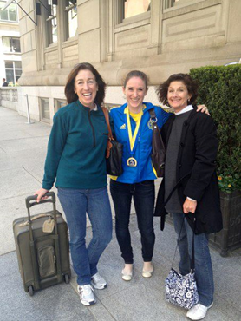
We spent the night eating my weight in pizza at the hotel. “How do you feel,” Laurie asked me. “I feel great….Can we take the elevator?”

We raised $4,390 for the Claudia Barr program at Dana-Farber, helping fund innovative cancer research!!! I cannot wait to see all of the good that will come out of this. Thank you for your cards, texts, notes of support and concern. I am so very grateful to have so many warm and kind people in my life. This was my first time running the Boston Marathon and my first time running in support of Dana-Farber - for my grandparents, for Auntie Penny, for Aunt Doris, and Laurie. And I am beyond grateful for having the chance to share in this experience with all of you. Your donation truly is going to an incredible cause, providing the resources for researchers to find treatments and cures for all different types of cancer.

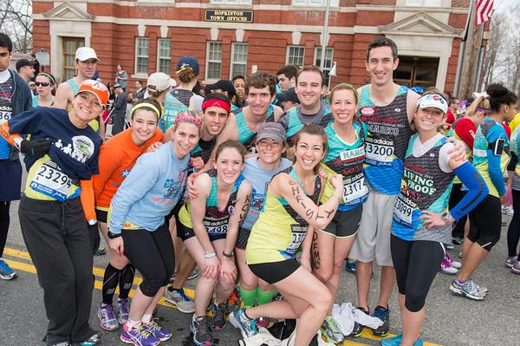
I’ve learned that where there is evil, there is an opportunity to create good. Through it all I’ve seen how much people have come together to support and care for each other, no questions asked. From the complete strangers who walked me to the Marriott to my friends who came to get me to safety to those who texted and called and checked-in to those who gave their resources to help others affected by cancer to those who came out to cheer. Everyone I’ve talked to has had similar experiences of people being so willing to care for complete strangers. Yes, this experience has changed me, but it’s changed me for the better. It’s made me a stronger person and more grateful than ever for the people I am surrounded by, their warm and giving hearts, and I can’t wait to come back next year stronger than ever and run with Dana-Farber. Boston Marathon 2014 here we come!

www.eliserunsboston.tumblr.com
http://rundfmc.org/2014/elisek

